

**Faculty of engineering - Shoubra**

**Benha University**

**Research Article / Research Project / Literature Review**

in fulfillment of the requirements of

|  |  |
| --- | --- |
| **Department** | Electric |
| **Division** | Communication |
| **Academic Year** | First year |
| **Course name** | Computer Application 1 |
| **Course code** | ECE 124C |

**Title: -**

**…Cars Project…**

By:

|  |  |  |  |
| --- | --- | --- | --- |
|  | Name | Edu mail | B.N |
| 1 | احمد اشرف قاسم محمد | Ahmed180023@feng.bu.edu.eg | 141003 |

**Approved by:**

|  |  |
| --- | --- |
| Examiners committee | Signature |
|  |  |
|  |  |
|  |  |
|  |  |
|  |  |

**Notes**

**Introduction**

The website that I have developed is about cars. I have used html, CSS, bootstrap and java script to create the website.

The website contains form with a validation for password, phone number and email

, also, the website contains gallery to show the cars in the cargo also contains nav bar, some paragraphs, video, iframe, list and table.

All the pervious elements are coordinated by CSS and bootstrap only in the form I used java script to validate it.

**Literature Review**

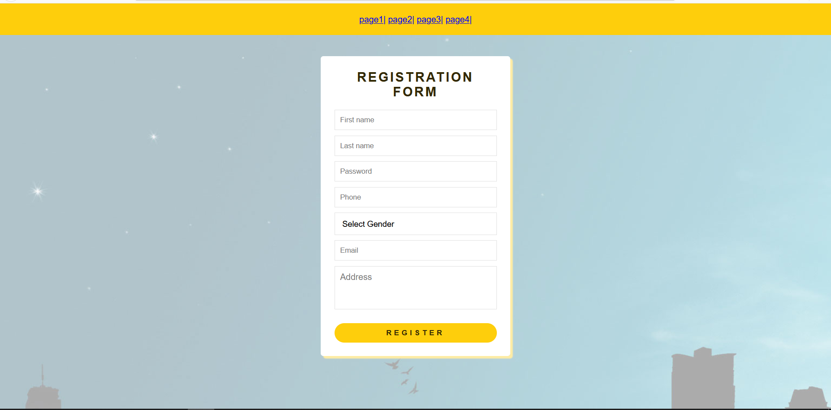

The previous photo shows the form that created with HTML, CSS and java script:

1-Navigation bar created using a list that contains links to other 4 pages for the website, each element is separated with {|} using CSS also the background coordinated by CSS.

2-The theme of this page is used in the other pages.

3-The form element created by HTML & coordinated using CSS:

1. The first name and last name is created by text input and given an

Id and name to help coordinate them.

b-The password field is created by password input and given an id

also, the password has got a validation using java script to verify:

• the password must start with uppercase character.

• the password must include 8 characters no more no less.

• the password must include one digit at least.

• the password must include one special character like {-, _, #, &, and *.}

• No white spaces allowed in the password

c-The email field is created by email input and verified using JS to confirm that the text written is in the correct form.

d-The phone number field is created by phone input and verified using JS to confirm that the input is only digits.

e-The gender selector is created using select element.

f-The submit button is created using submit attribute to register the form.

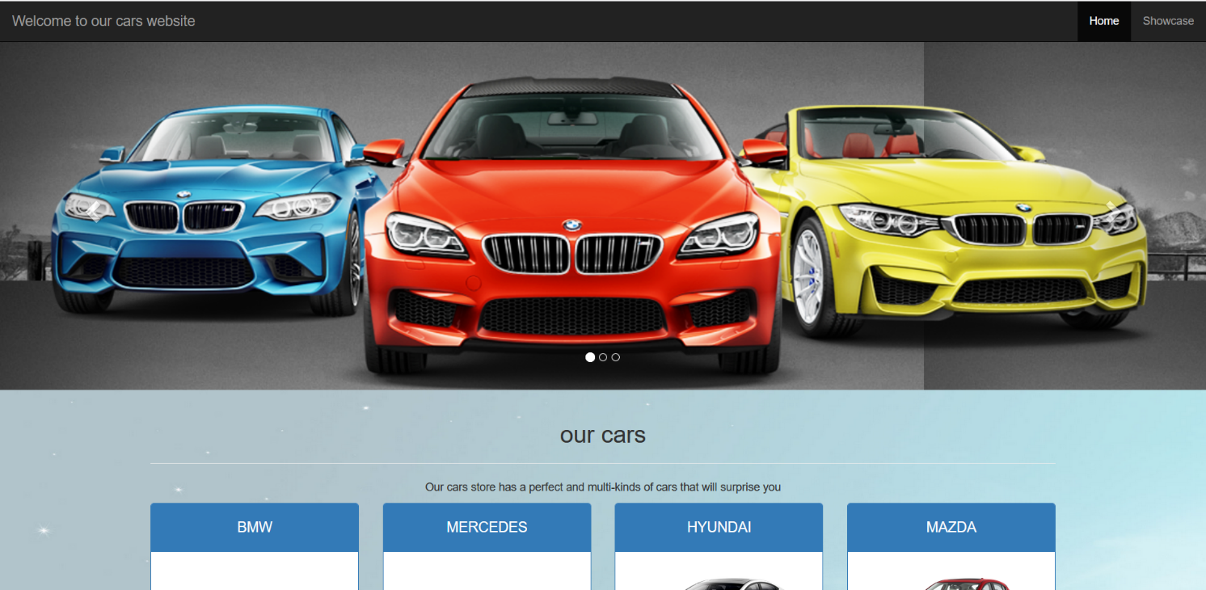

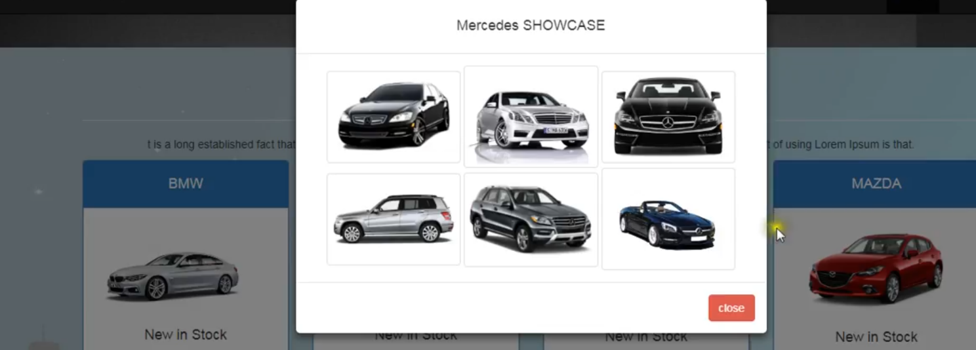

This page has a nav bar that contain 2 items [Home-Showcase]:

1-While pressing at home item it opens the main page.

2-While pressing at Showcase it leads to the stock to pick a model.

The next scrolling carousel contains 3 moving photo that you can move it manually by pressing the next or previous button and has a certain background.

The stocks below the scrolling carousel consist of 4 stocks for 4 different model of cars [BMW-MERCEDES-MAZDA-HYUANDAI].

If you click the button [View Gallery] it will show 6 models of cars from the same type.

Every section of this page has a multi classes to coordinate them using CSS and Bootstrap.

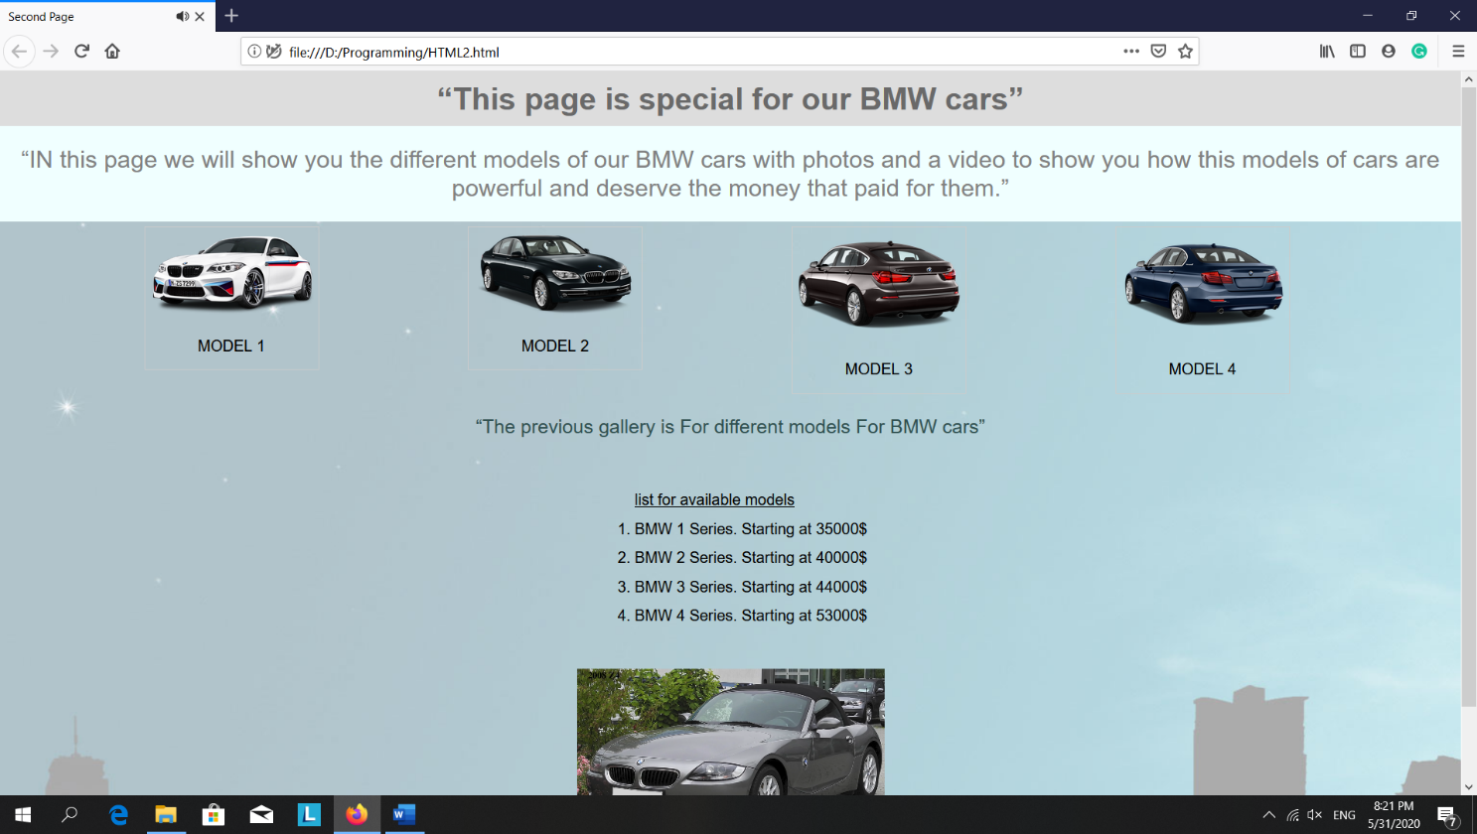

This page shows the first model of the cars in the stock [BMW].

I used a header then a paragraph at the beginning of this page and I coordinated them using CSS.

The gallery in this page shows the different models of BMW cars each photo has a certain width and height.

The list in this page shows the 4 available models and their prices.

The video in this page prove the top 10 cars of BMW that will be available in the stock soon.

Each element in this page was coordinated using CSS.

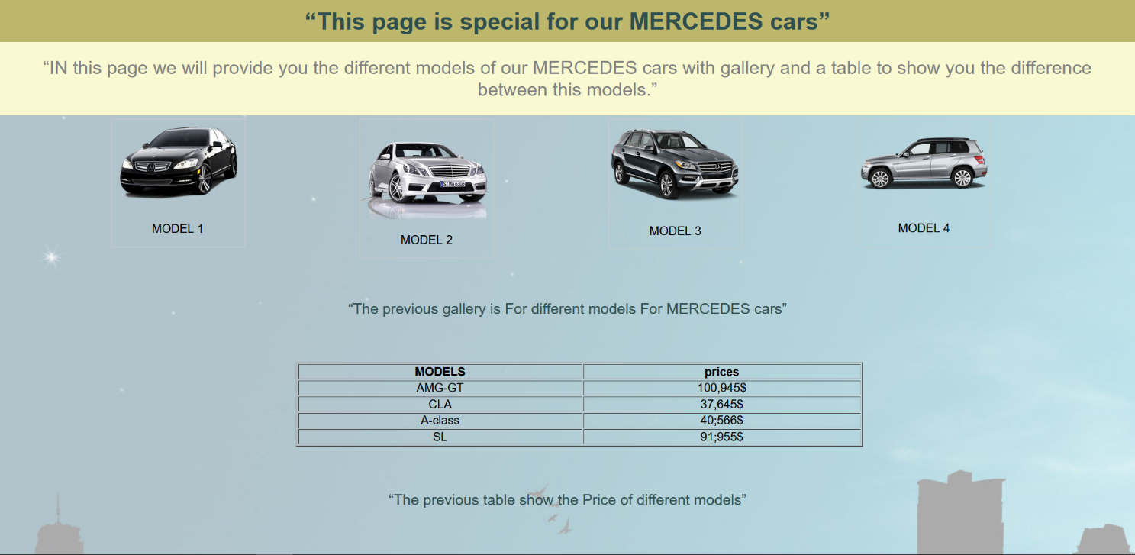

This page shows the second model of the cars in the stock [MERCEDES].

I used a header then a paragraph at the beginning of this page and I coordinated them using CSS.

The gallery in this page shows the different models of MERCEDES cars each photo has a certain width and height.

The table in this page shows the 4 available models and their prices

Each element in this page was coordinated using CSS.

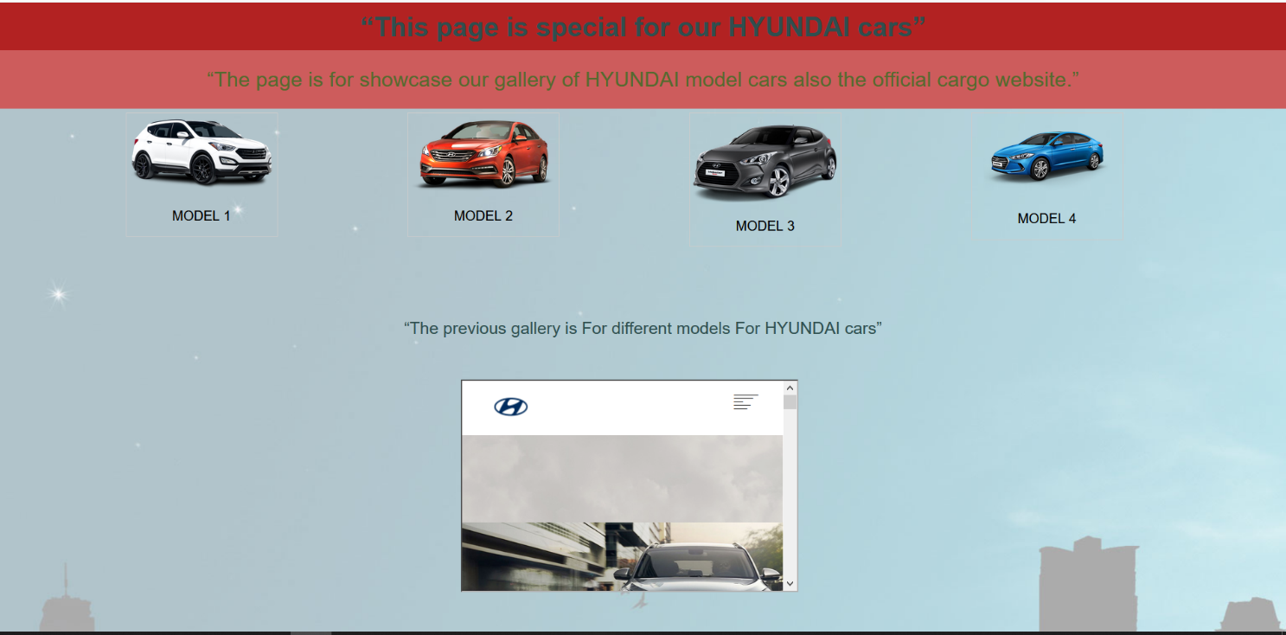

This page shows the second model of the cars in the stock [HYUNDAI].

I used a header then a paragraph at the beginning of this page and I coordinated them using CSS.

The gallery in this page shows the different models of MERCEDES cars each photo has a certain width and height.

The iframe used in this page is to access the official page of HYUNDAI cars store in Egypt .